**7 Испытание: пирамиды**

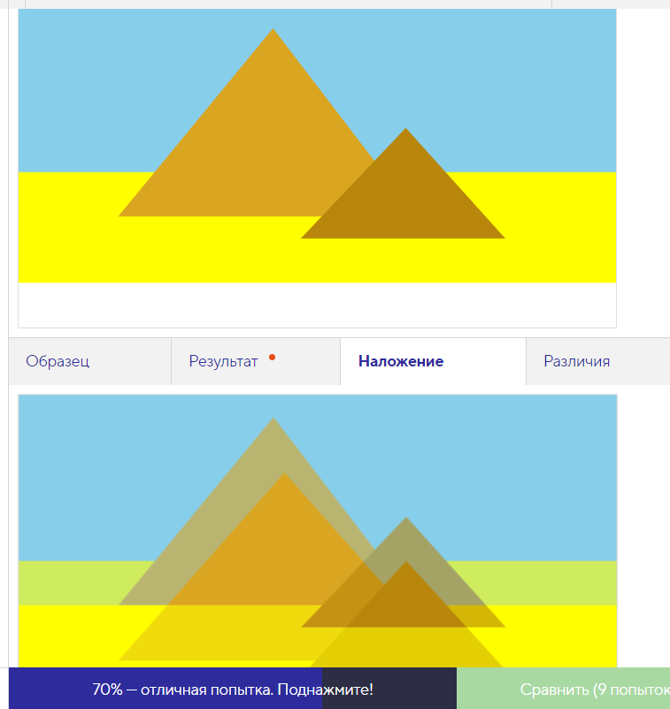

<svg width="540" height="290">

<rect width="100%" height="250" fill="yellow"/>

<rect width="100%" height="150" fill="skyblue"/>

<polygon points="90,190 230,20 360,190" fill="goldenrod"/>"

<polygon points="350,110 440,210 255,210" fill="darkgoldenrod"/>"

</svg>

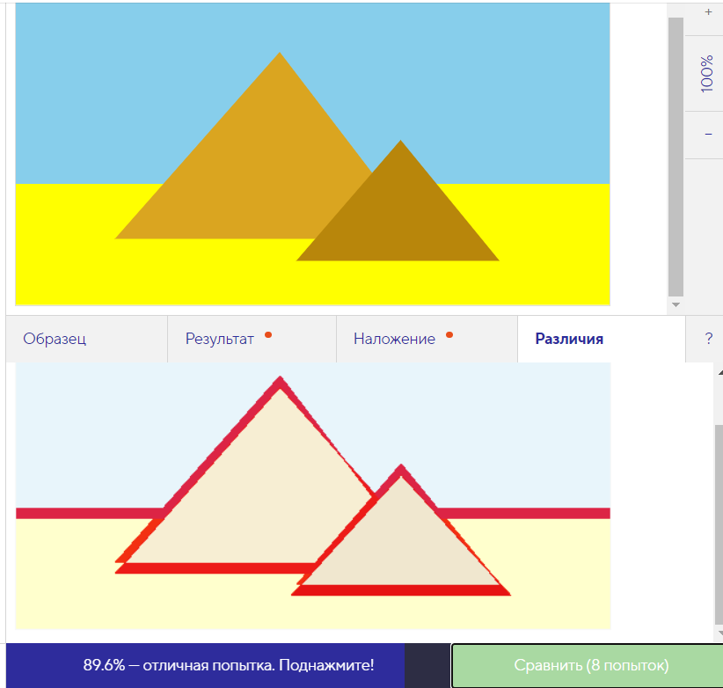

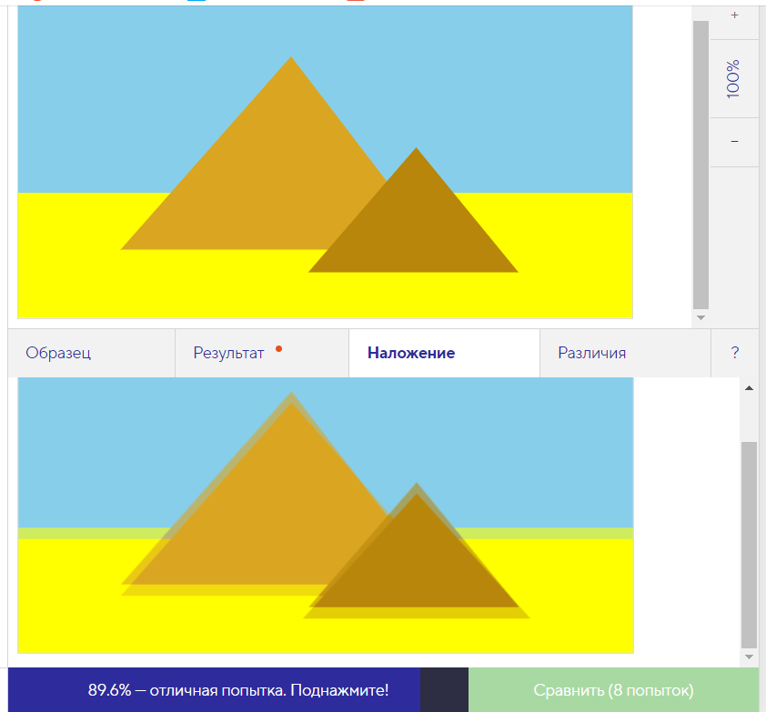

<svg width="540" height="290">

<rect width="100%" height="290" fill="yellow"/>

<rect width="100%" height="180" fill="skyblue"/>

<polygon points="90,230 240,60 370,230" fill="goldenrod"/>"

<polygon points="350,140 440,250 255,250" fill="darkgoldenrod"/>"

</svg>

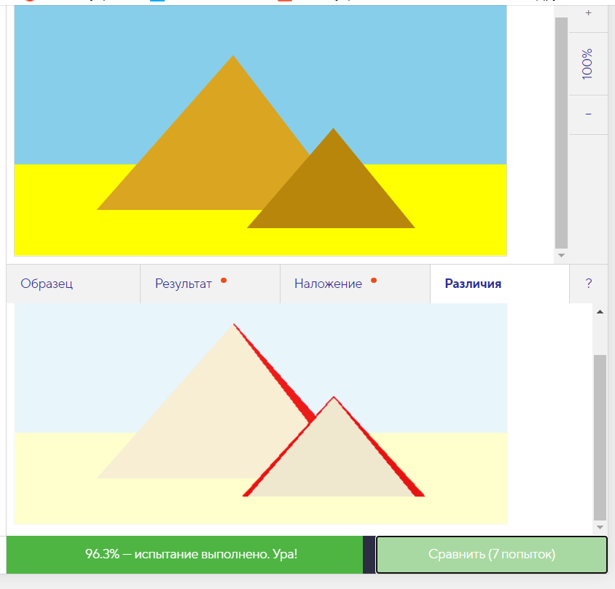

<svg width="540" height="290">

<rect width="100%" height="290" fill="yellow"/>

<rect width="100%" height="190" fill="skyblue"/>

<polygon points="90,240 240,70 370,240" fill="goldenrod"/>"

<polygon points="350,150 440,260 255,260" fill="darkgoldenrod"/>"

</svg>